EMBARGOED UNTIL Monday, May 25, 2026, at 6:00 PM EST (UTC-4)

Introducing MOMENTUM 5 Wireless: Your Sound Revelation Starts Here
The Sennheiser brand’s newest portable powerhouse is an escape into high-fidelity sound, enriched with spatial audio and a suite of sophisticated capabilities.

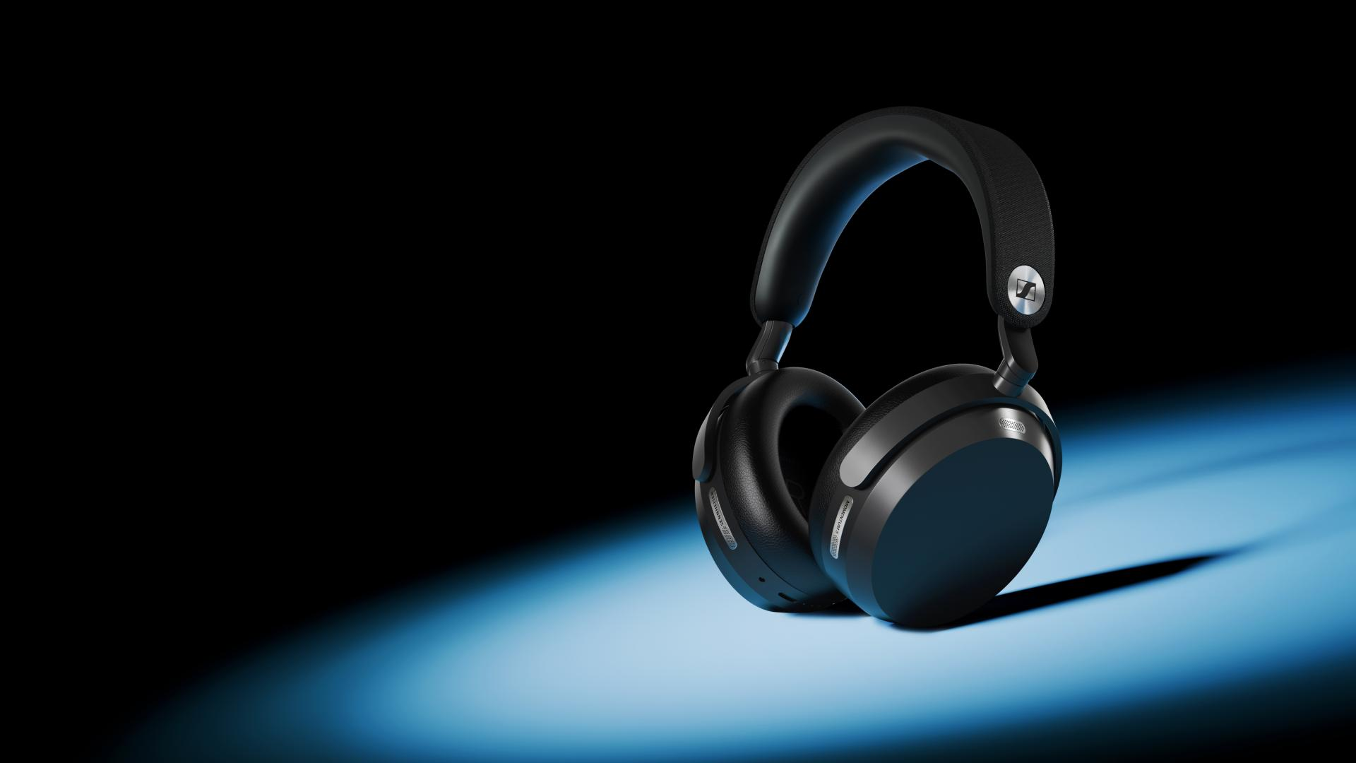

Hanover, Germany – May 25, 2026 – The Sennheiser brand today announces MOMENTUM 5 Wireless, the most capable and user-focused evolution of the acclaimed headphone series yet. The newest MOMENTUM preserves the category-defining sound and battery performance of the platinum-selling line while introducing meaningful enhancements to elevate everyday listening for the modern audio enthusiast.
"With MOMENTUM 5 Wireless, we focused on refining the entire experience without straying from the formula that made its predecessor such a success," said Product Manager Sreenath ‘Sri’ Unnikrishnan, "These enhancements enrich the overall functionality while still capturing the magic you feel every time you press play.”
Signature Performance
MOMENTUM 5 Wireless carries forward the acclaimed 42mm transducer from its predecessor, which is meticulously manufactured at the brand’s state-of-the-art facility in Tullamore, Ireland. It is inspired by the famed HD 600-series headphones and tuned for full-bodied sound with dynamic bass. This latest generation MOMENTUM advances its sonic possibilities even further with Hi-Res Audio certification, and Snapdragon Sound™ technology featuring BluetoothⓇ audio codec support up to aptX™ Lossless. Using the free Smart Control Plus companion app’s new 8-band EQ, bespoke presets, and intelligent Sound Personalization engine, the iconic house sound can be shaped to practically any preference with ease.

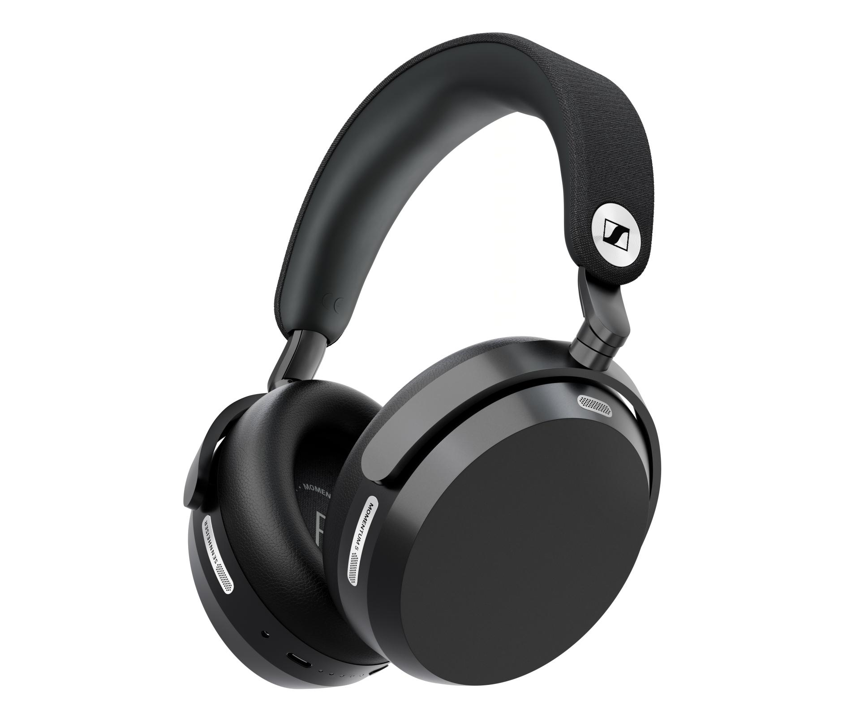
MOMENTUM 5 Wireless features spatial audio with head-tracking and a user-replaceable battery

Total Immersion
The newest MOMENTUM’s rich and exciting sound is further magnified by what the listener won’t hear, as it is up to three times more effective at reducing distracting voice chatter with its supercharged active noise cancelling system. The number of microphones dedicated to ANC and transparency duties has doubled, with four microphones per side yielding across-the-board improvements at reducing droning airplane cabin noise and more natural voice quality on calls.

Designed to improve over time, the MOMENTUM 5 Wireless platform gives owners new and optimized capabilities through firmware updates to the DSP and wireless engines. For example, early adopters will be greeted with day one updates, unlocking Dolby AtmosⓇ with head-tracking for next-level immersion when listening to supported Atmos encoded content¹. Furthermore, the hardware ships with Bluetooth 5.4 out of the box and is engineered for the future—the headphones are ready for Bluetooth 6.0 via a future firmware release. The combination of immersive audio, improved ANC and jaw-dropping sound delivers a sound revelation for brand newcomers and seasoned listeners alike.


MOMENTUM 5 Wireless boasts up to 3x more effective ANC against ambient voices

“With MOMENTUM 5 Wireless, we’re proving that high-performance sound and environmental responsibility can — and must — exist in the same product. With our new user-swappable battery, adaptable hardware, and shift to compact, plastic-free packaging, our customers will feel proud to choose a headphone meant to last.” added Lilika Beck, President, Sennheiser Consumer Audio.

Refreshingly Responsible
MOMENTUM 5 Wireless remains an endurance champion with quick charging and up to 57 hours of battery life per charge with ANC engaged. This generation also introduces a user-replaceable 700 mAh battery, engineered to meet strenuous standards for daily use with zero impact on acoustic performance. Using only a small Phillips-head screwdriver, owners can refresh the power cell in minutes, ensuring the headphones stay in their daily rotation for years to come. This commitment to efficiency also extends to the storage case—now 20% smaller—and smaller, plastic-free packaging designed to minimize the total environmental footprint during transit. Also included in the case are a USB Type-C charging cable and 3.5mm analog audio cable for connection to in-flight entertainment systems, laptops, and more.

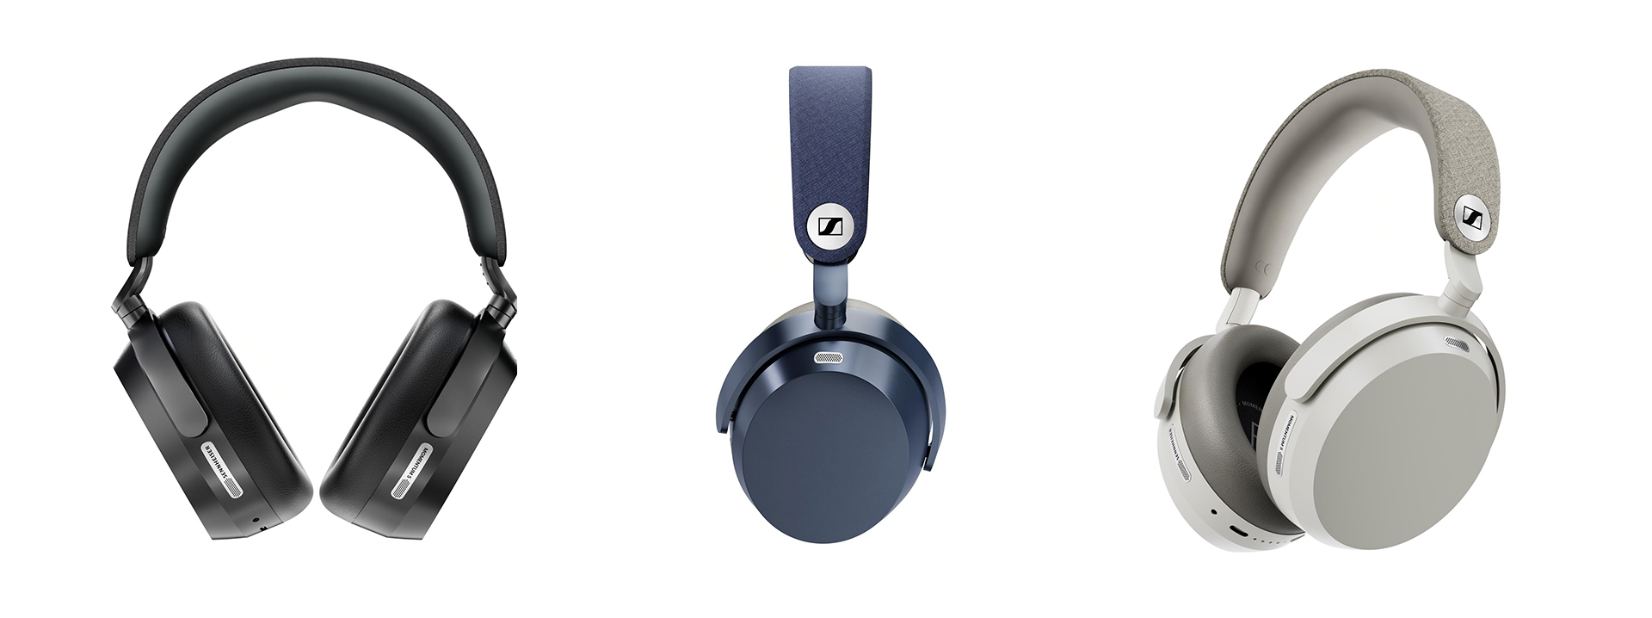
MOMENTUM 5 Wireless in black, denim, and white colorways

Availability
MOMENTUM 5 Wireless will be available in Black, White, and Denim colorways, with a suggested retail price of $569.95 USD. Audio enthusiasts in the USA can get their sound revelation starting June 16th at sennheiser-hearing.com and select retailers.

¹ Immersive audio and head-tracking require a firmware update via the Smart Control Plus app. Playback requires an Atmos-enabled source device and content from supported spatial audio platforms.

The Bluetooth® word mark and logos are registered trademarks owned by Bluetooth SIG, Inc. and any use of such marks by Sonova Consumer Hearing is under license. Android is a trademark of Google LLC. iOS is a trademark or registered trademark of Cisco in the U.S. and other countries and is used under license by Apple Inc. Snapdragon Sound and aptX are trademarks or registered trademarks of Qualcomm Technologies, Inc. and/or its subsidiaries. aptX is a product of Qualcomm Technologies, Inc. and/or its subsidiaries. Dolby, Dolby Atmos, and the double-D symbol are registered trademarks of Dolby Laboratories Licensing Corporation. All other company and product names mentioned herein may be trademarks of their respective companies.

About the Sennheiser Brand – 80 Years of Building the Future of Audio
We live and breathe audio. We are driven by the passion to create audio solutions that make a difference. This passion has taken us from the world’s greatest stages to the quietest listening rooms – and made Sennheiser the name behind audio that doesn’t just sound good: It feels true. In 2025, the Sennheiser brand celebrated its 80th anniversary. Since 1945, we have stood for building the future of audio and bringing remarkable sound experiences to our customers. While professional audio solutions such as microphones, meeting solutions, streaming technologies and monitoring systems are part of the business of Sennheiser electronic SE & Co. KG, the business with consumer devices such as headphones, soundbars and speech-enhanced hearables is operated by Sonova Holding AG under the license of Sennheiser.

sennheiser.com
sennheiser-hearing.com

About Sonova Consumer Hearing
Sonova Consumer Hearing offers premium headphones and hearables – primarily in the true wireless segment – as well as audiophile headphones, hearing solutions and soundbars under the Sennheiser brand. The business is part of the Sonova Group, a global leader in innovative hearing care solutions with headquarters in Switzerland and more than 17,000 employees worldwide.

Press contact
Eric Palonen
PR Manager | Americas
Sonova Consumer Hearing USA
T +1 860 908 1210
eric.palonen@sonova.com

